Assignment No. 4 - CSC 102 (Fall 2025)
Assigned on: 09-12-2025 CLO: 5 Unit: 8 Due Date: 19-12-2025

Name : ___________________________________________ ID: _______________ Program & Section: ______________

1. Compiler processes pre-fix or post-fix expression for evaluating any in-fix expression. Construct ordered rooted tree for converting following in-fix expression into post-fix form. Also write the equivalent post-fix expression. (5 Marks)
8 + (9 – 4 * 3 / (5 + 7)) * 2
Solution:

Post-fix expression:
- Consider the following graph. Count the paths of length 2 in this graph. (5 Marks)

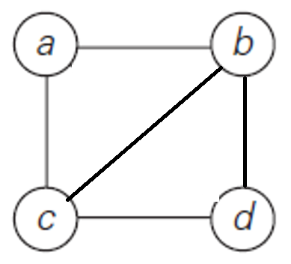
Solution:
